Voluntra Project Documentation

- Project Brief: A platform for volunteers to find opportunities and NGOs to post Events.
And RPA automates volunteer matching Requirements based on skills and preferences.
- Project name: Voluntra
- Developer: Farah Kullab
- Submission Date: Saturday 25.jan.2025
- Goals: making it easier for Volunteers to find Volunteering Opportunities. The platform allows NGOs to Post the Events Opportunities, manage Events, while Volunteers can easily browse, and submission to events depends on their preferences.
- Prerequisites: Using technologies (ASP.NET core MVC / HTML / CSS / JS / SQL/RPA for Automation)
using Visual Studio Tool and UiPath Studio.
- Target Users: (NGOs, volunteers).
- How to Run the website:
the website starts with home page that contain the registration and login form and the main sections
-Navbar with Home/ About /Events/Blog/Feedback
- NGO section for NGOs signing up our website.
-Our Areas of work section.
-Visitors Feedback messages section.
- Feedback section
-Footer Contain Form for Quick Contact
(the Volunteers can browse the website , show all the NGOs and Their profile , and the events that Posted from the different NGOs and the NGOs can register and create account in the website to posting the events and manage their profiles).
- Home Page (Main sections):
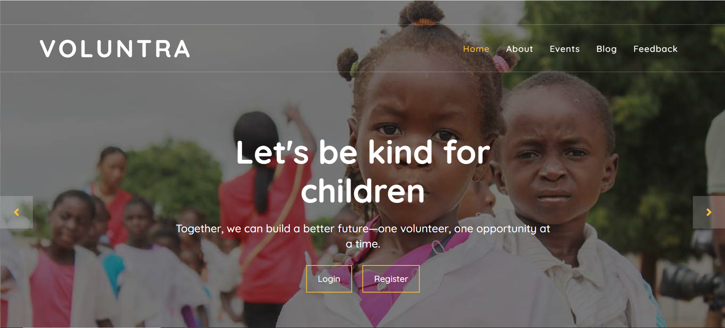

- Popular NGOs section:
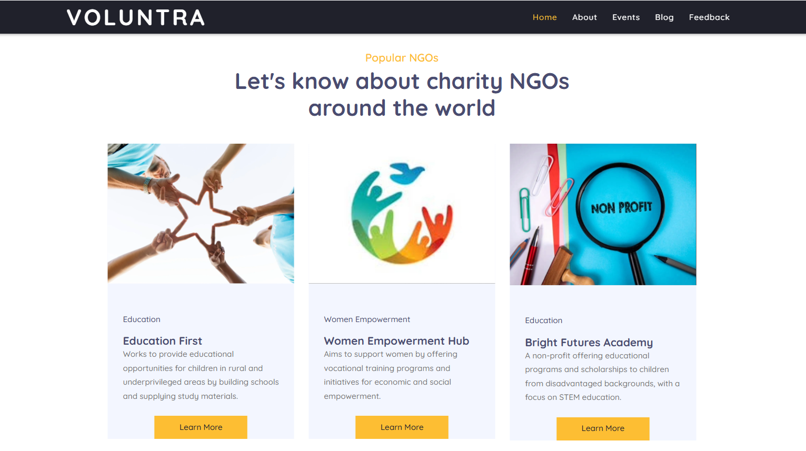

- Areas of work section :
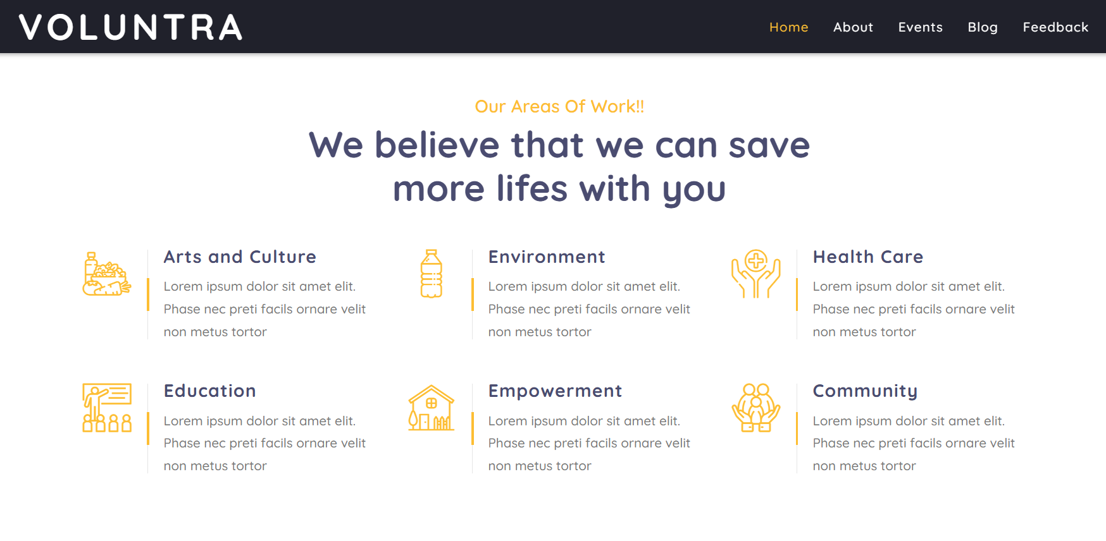
- Feedback Messages Section :
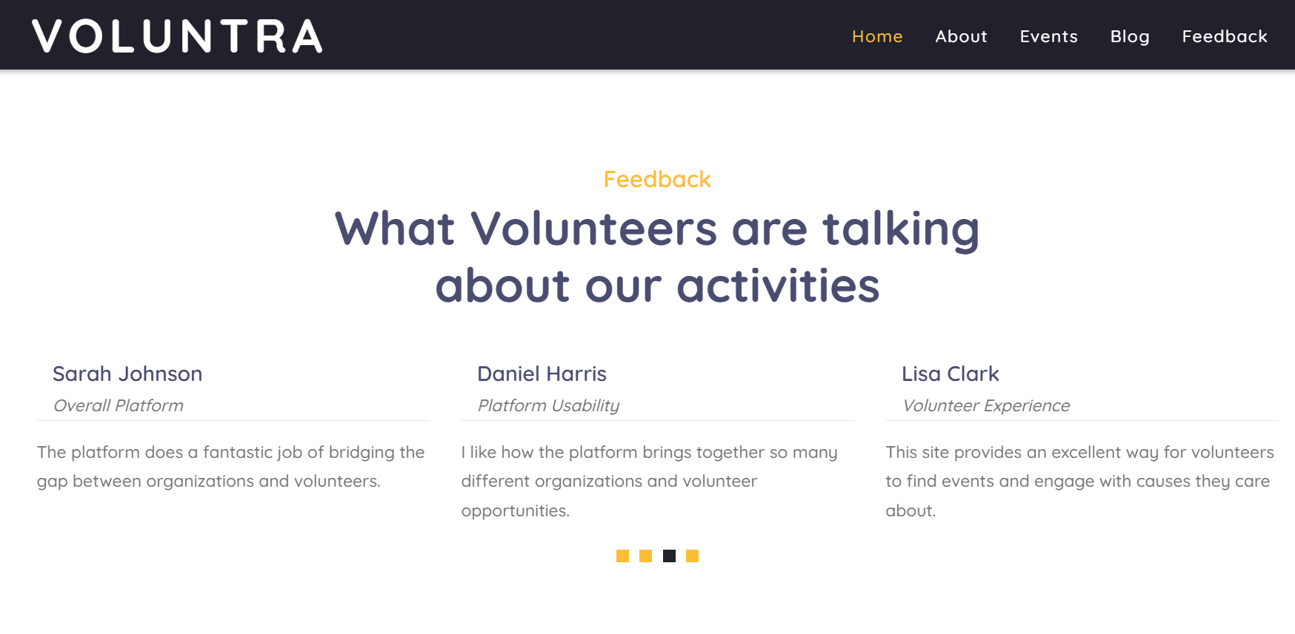

- Feedback Form section :
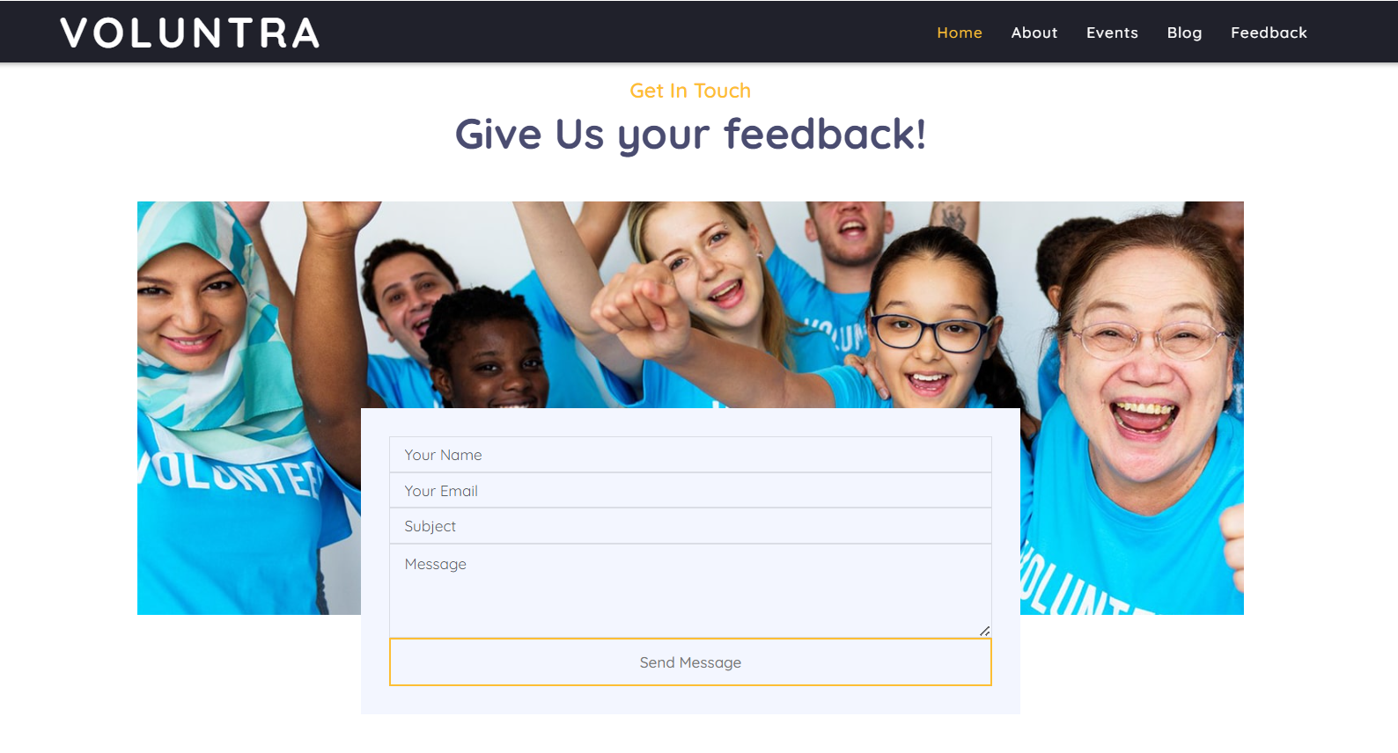
- Footer section :
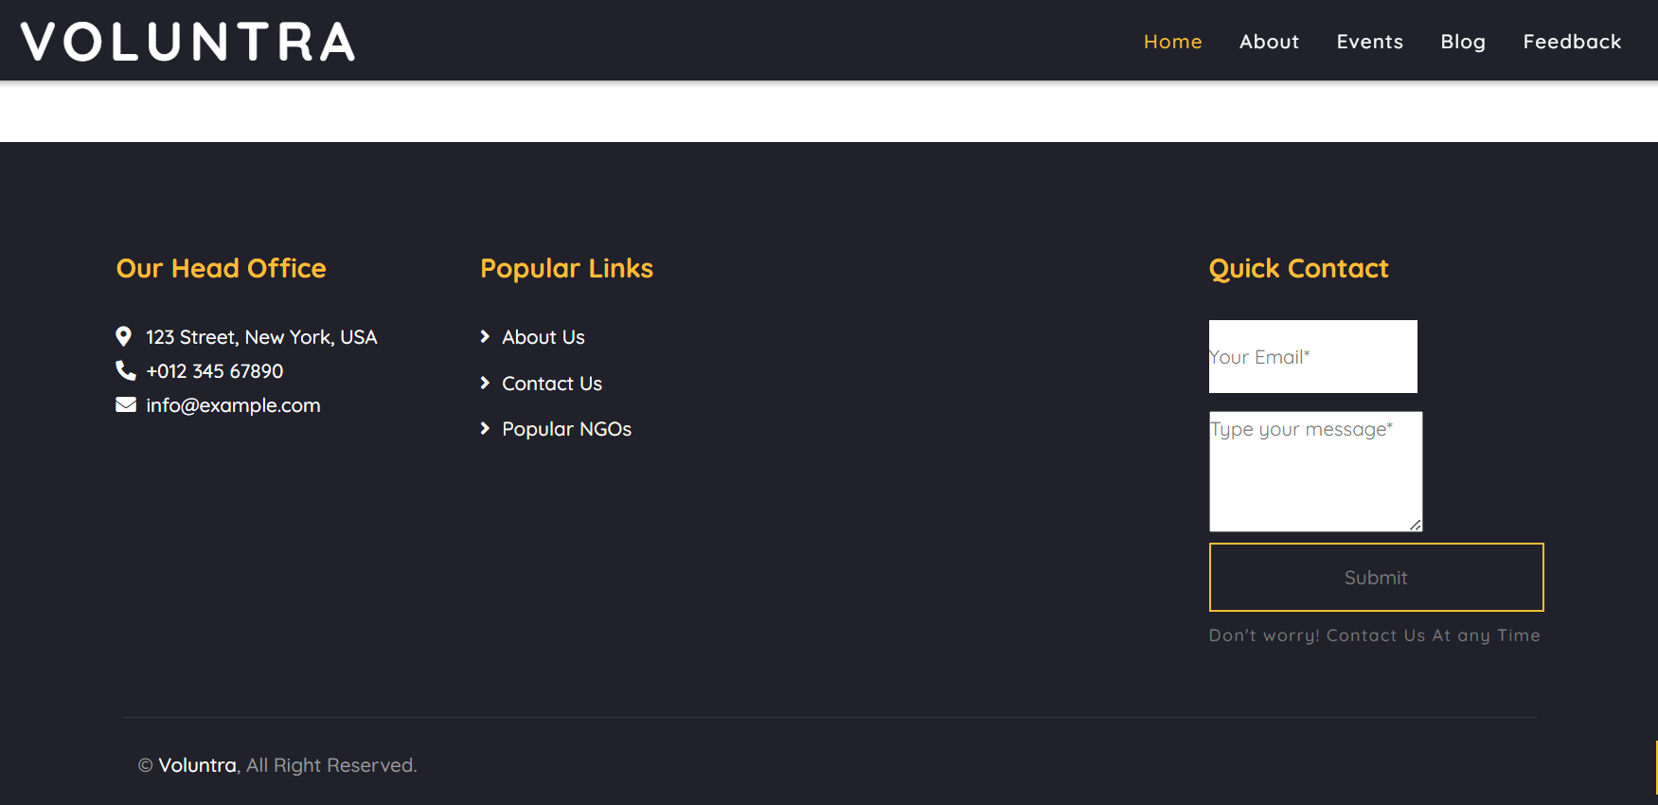

- About Section:
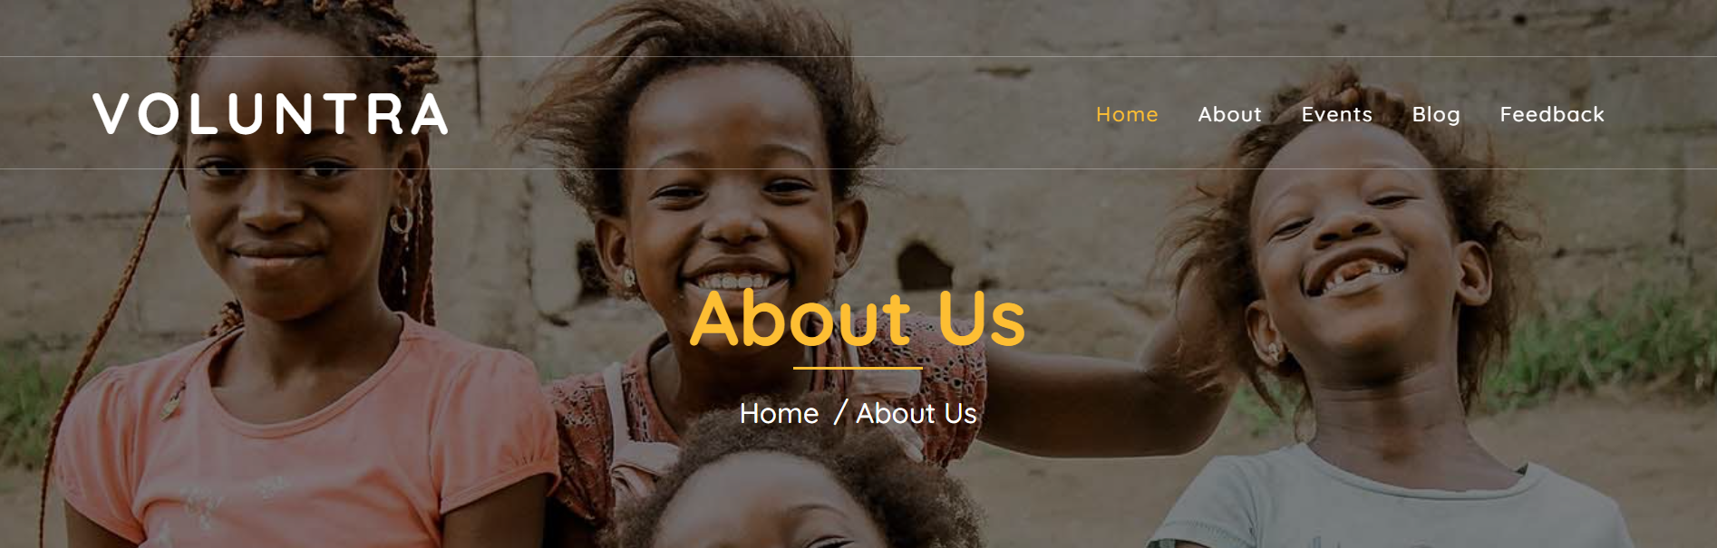

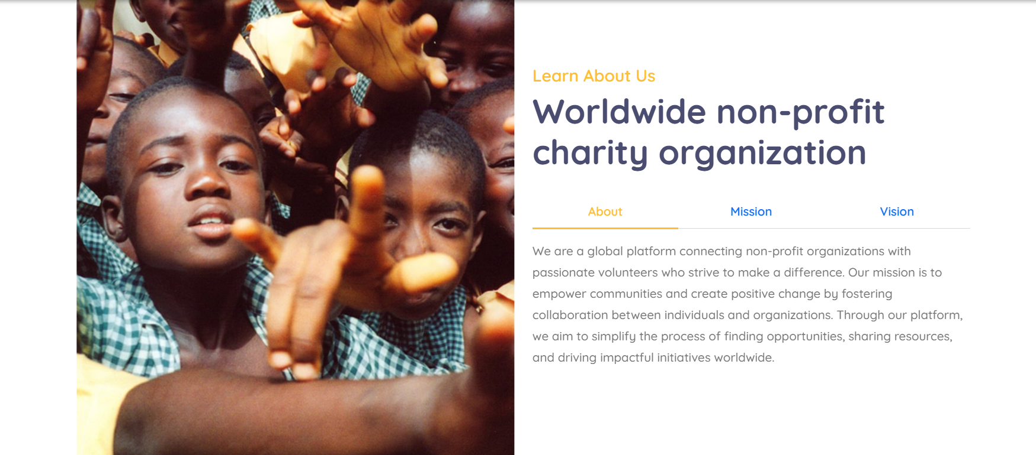

- Upcoming Events :
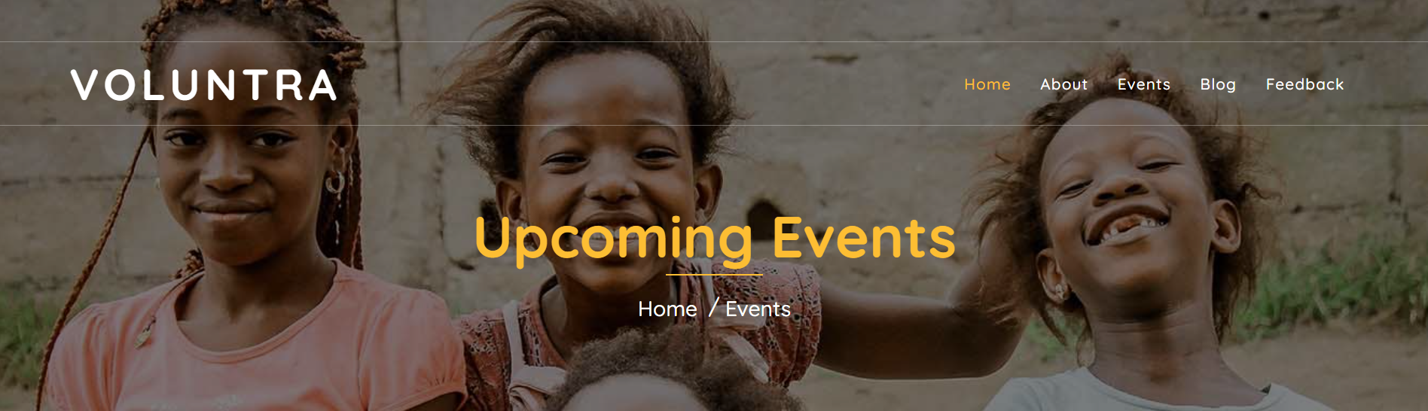

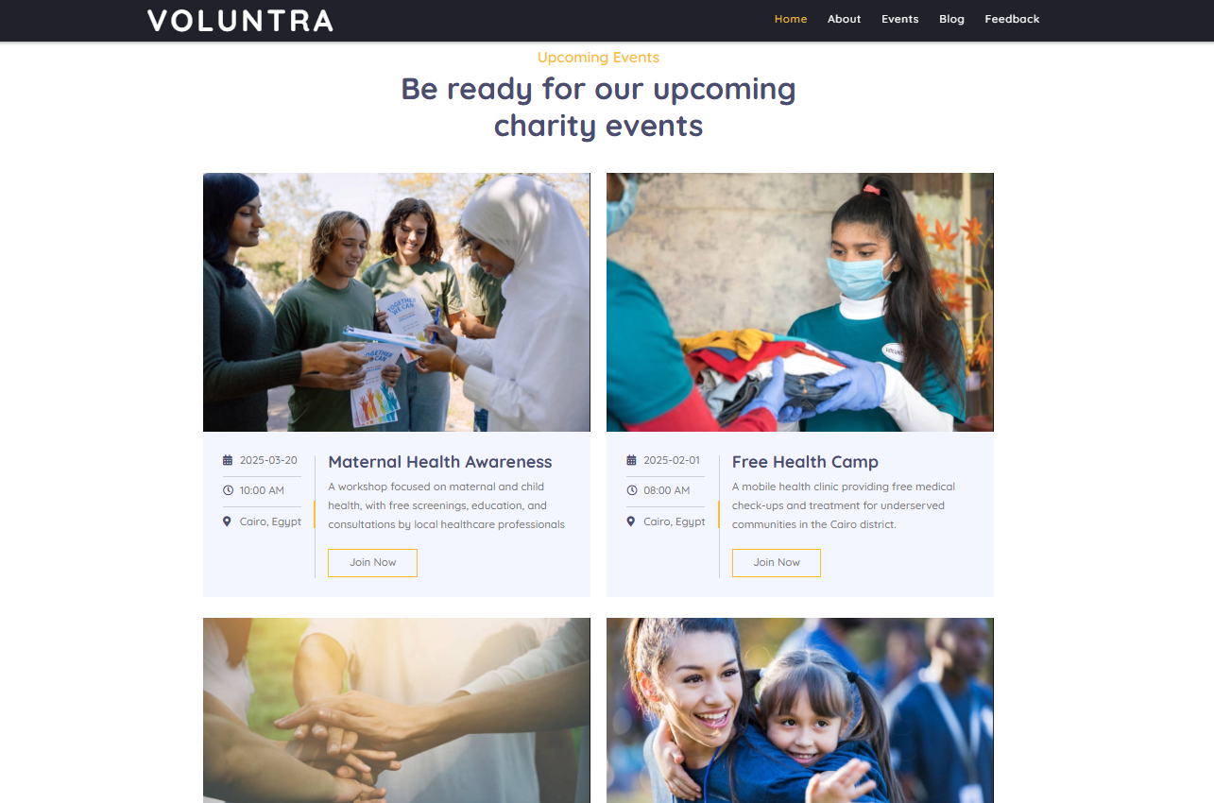

- Phase 2 Feature :
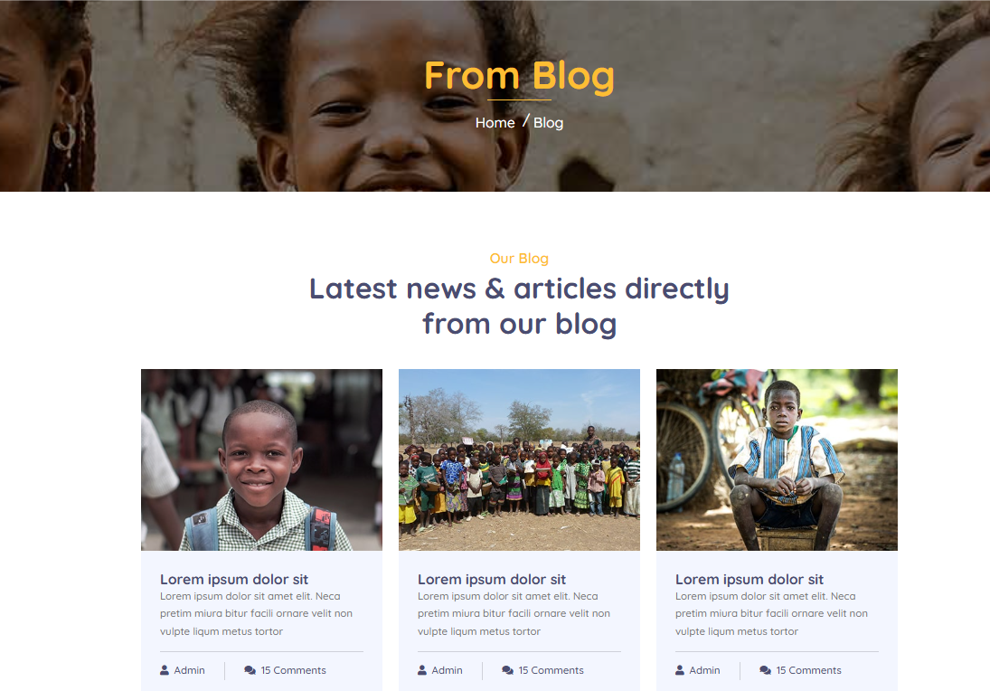

- Login Page :
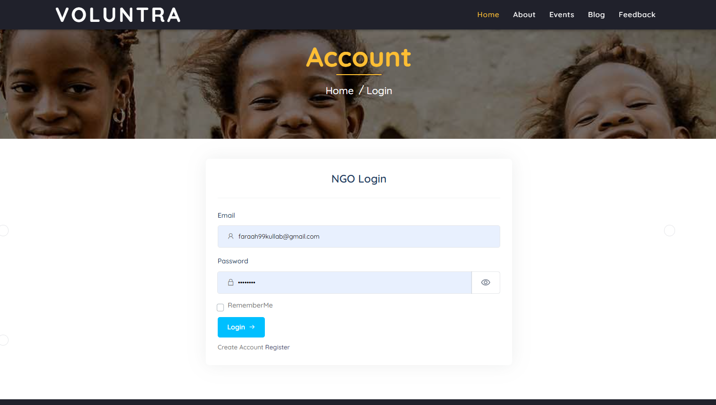
- Register Page :
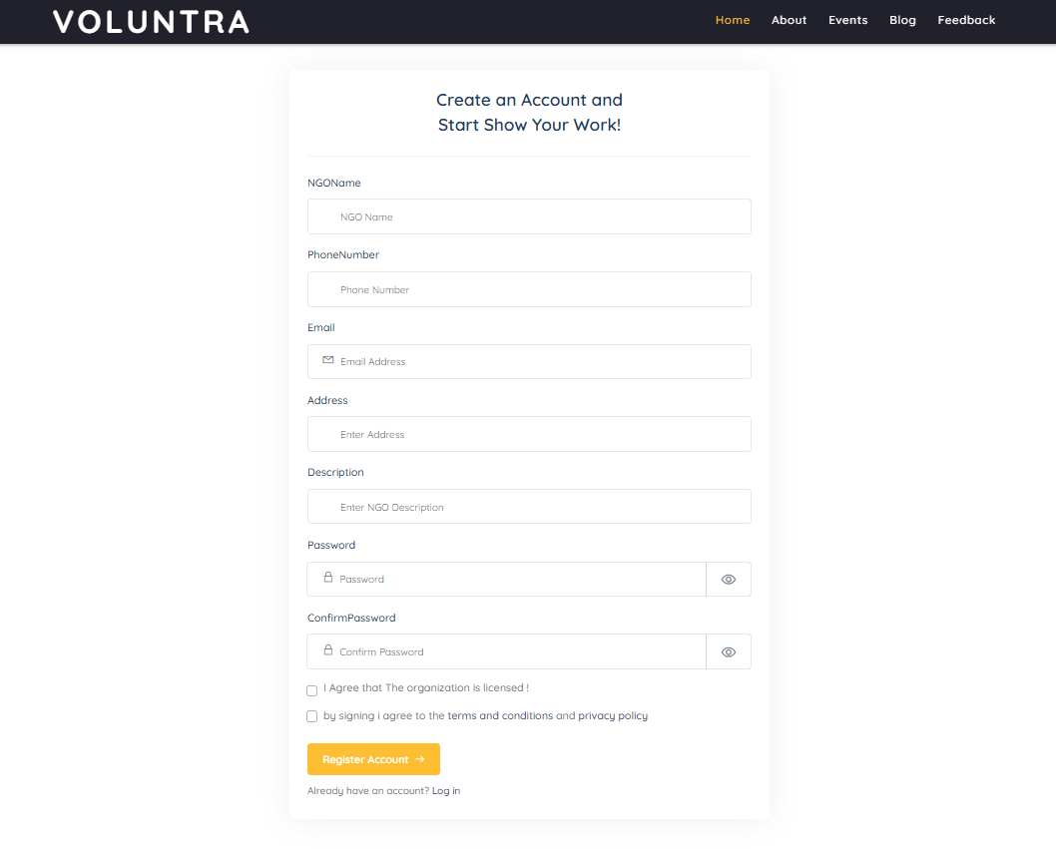
- Admin Dashbord:
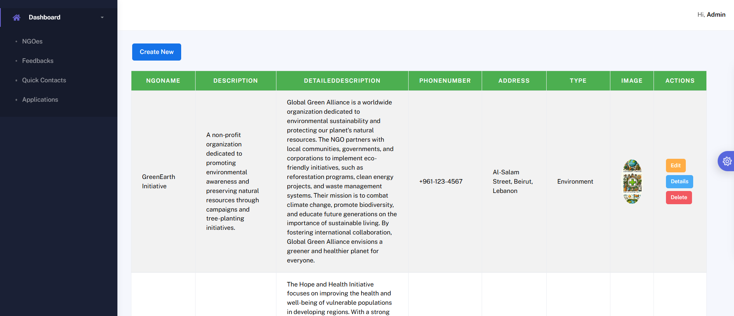

- Editor Dashboard :
